1. **Addition of Two Numbers:**

1. **Simple Interest Calculation:**

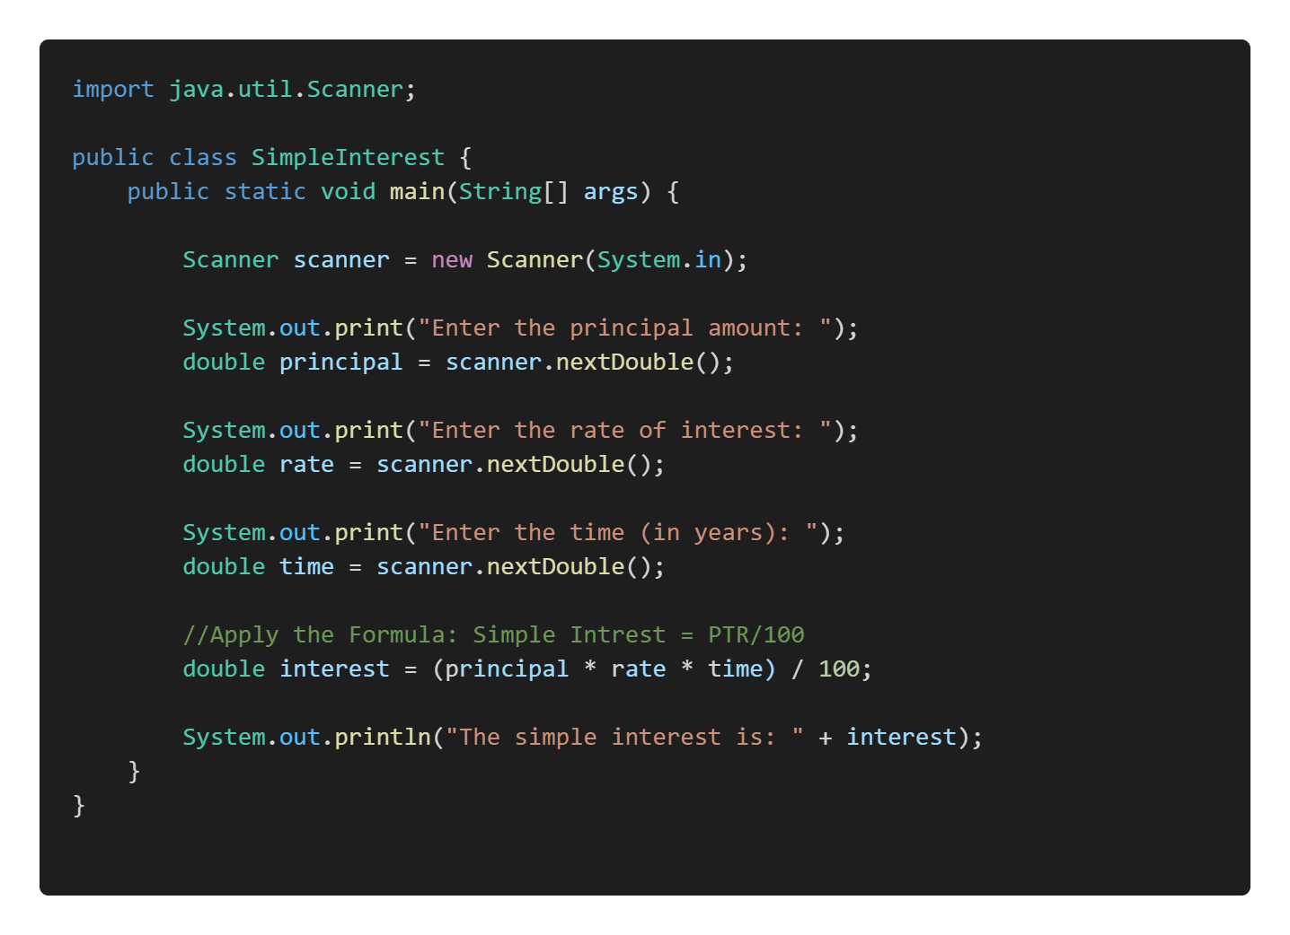

1. **Check the Number is Positive, Negative, or Zero:**

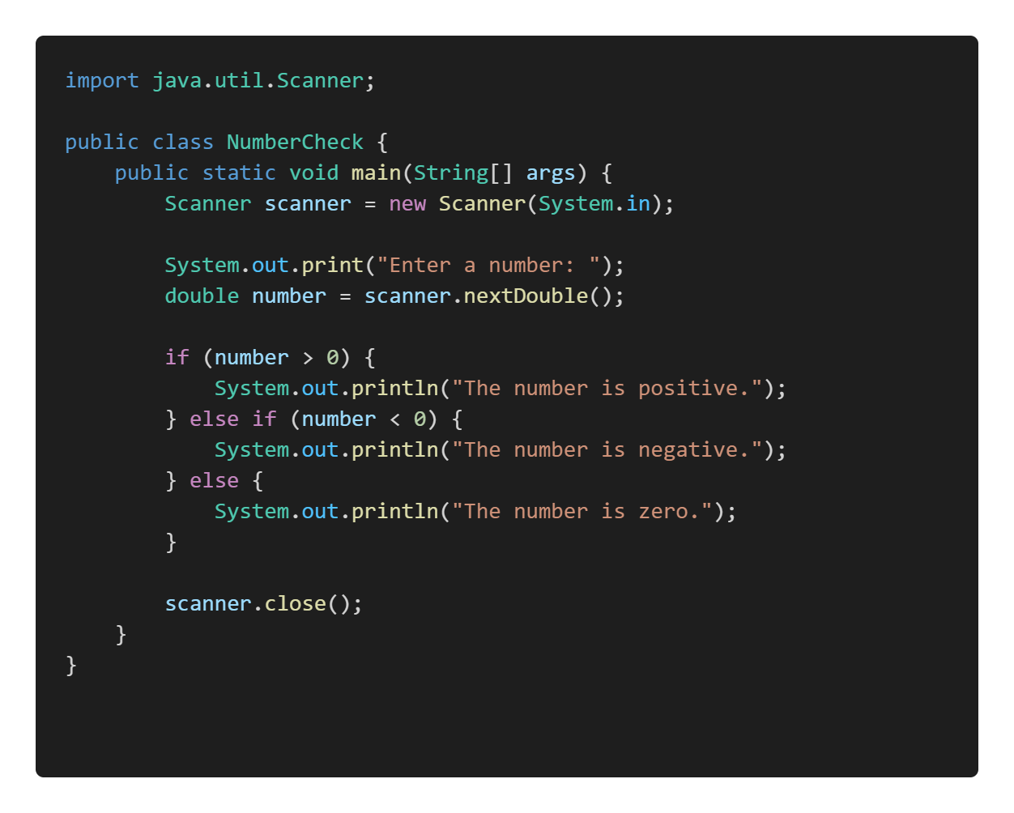

1. **Simple Java program that takes input from the user (student name, Roll No and marks for different subjects), calculates the total marks, average, and grade, and then prints the results.**

1. **Multiplication Table:**

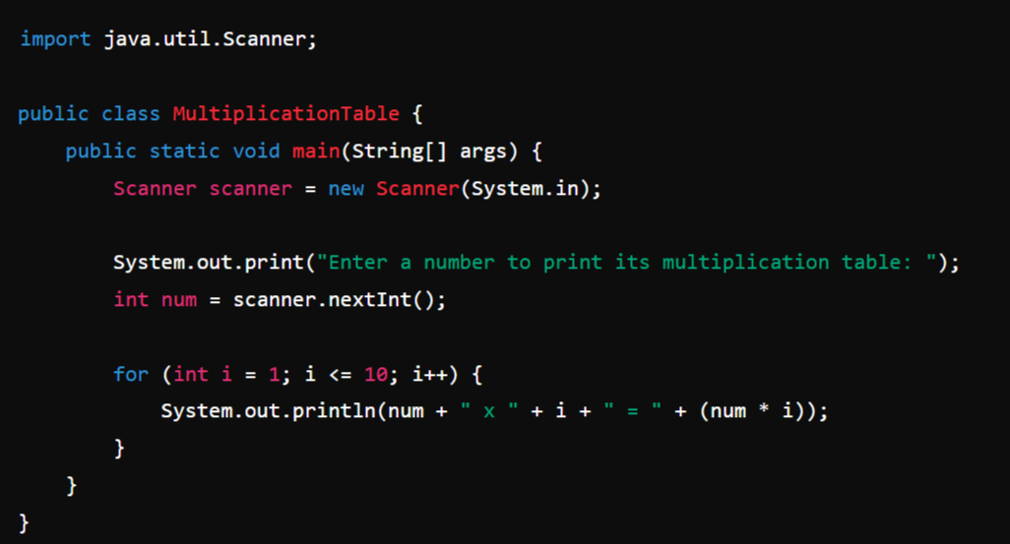

1. **Find the Largest of Two Numbers:**

**Exercise: Write the Java Code for Below Programs:**

1. Find the **Largest** **of** **Three** **Numbers**
2. Check **Even** or **Odd** Number
3. **Factorial** of a Number
4. **Simple** **Calculator** with Addition, Substraction,Mul, Div, Mod.
5. Check if a Number is **Even** or **Odd**.